**THE**

**"GOOD NEWS"**

**AND**

**"SEVEN ONES"**

BODY, SPIRIT, HOPE

LORD, FAITH

BAPTISM, GOD

I CORINTHIANS 15:1-4 EPHESIANS 4:4-6

Correspondence Course - Student

Lesson 1 and Lesson 2

By David Ballard

KJV Version

PDF Presentation Video Lessons

 

The Seven Ones

Eph 4:4 *There is* one body, and one Spirit, even as ye are called in one hope of your calling;

Eph 4:5 One Lord, one faith, one baptism,

Eph 4:6 One God and Father of all, who *is* above all, and through all, and in you all.

**LESSON 1**

The ONE GOD, The ONE LORD, and the BIBLE

Do you believe that God is the creator

of heaven and earth?

1. ______________________________

Gen 1:1 In the beginning 2. ____________ the heaven and the earth.

Gen 1:2 And the earth was without form, and void; and darkness *was* upon the face of the deep. And 3. ______________________ upon the face of the waters.

Gen 1:3 And 4. ________, Let there be light: and there was light.

Gen 1:4 And God saw the light, that *it was* good: and God divided the light from the darkness.

Gen 1:5 And God called the light Day, and the darkness he called Night. And the evening and the morning were the first day.

Rom 1:20 For 5. ________________ of him from the creation of the world 6. _______________, being understood by the things that are made, *even* his eternal power and Godhead; so that they are 7. ___________________:

Rom 1:21 Because that, when they knew God, they glorified *him* not as God, neither were thankful; but became vain in their imaginations, and their foolish heart was darkened.

Do you need more assurance? Search here.

<https://video.wvbs.org/program/evidence-for-god/>

<https://video.wvbs.org/program/evidence-for-jesus/>

<https://video.wvbs.org/program/evidence-for-the-bible/>

God Created!

Do you believe that Jesus is

the Son of God?

8. __________________________________

Rom 1:1 Paul, a servant of Jesus Christ, called *to be* an apostle, separated unto the gospel of God,

Rom 1:2 (Which he had promised afore by his prophets in the holy scriptures,)

Rom 1:3 Concerning 9. __________________

our Lord, which was made of the seed of David according to the flesh;

Rom 1:4 And declared *to be* the 10. _______ _______with power, according to the spirit of holiness, by 11. ________________ from the dead:

Rom 1:5 By whom we have received grace and apostleship, for obedience to the faith among all nations, for his name:

Rom 1:6 Among whom are ye also the called of Jesus Christ:

Jesus is indeed the Son of God!

Do you believe that Jesus is God?

This question may cause you to think a little more than the questions before.

But it is a question that, according to Jesus, your salvation depends upon.

12._________________________________

Joh 1:1 In the beginning was the Word, and the Word was with God, and 13. __________ ____________.

Joh 1:2 The same was in the beginning with God.

Joh 1:3 All things 14. _______________; and without him was not anything made that was made.

Joh 1:4 In him was life; and the life was the light of men.

Joh 1:5 And the light shineth in darkness; and the darkness comprehended it not.

Joh 1:6 There was a man sent from God, whose name *was* John.

Joh 1:7 The same came for a witness, to bear witness of the Light, that all *men* through him might believe.

Joh 1:8 He was not that Light, but *was sent* to bear witness of that Light.

Joh 1:9 *That* was the true Light, which lighteth every man that cometh into the world.

Joh 1:10 He was in the world, and 15. ______ ____________________, and the world knew him not.

Joh 1:11 He came unto his own, and his own received him not.

Joh 1:12 But as many as received him, to them gave he power to become the sons of God, *even* to them that believe on his name:

Joh 1:13 Which were born, not of blood, nor of the will of the flesh, nor of the will of man, but of God.

Joh 1:14 And the Word was made flesh, and dwelt among us, (and we beheld his glory, the glory as of 16. ___________________

______________,) full of grace and truth.

Joh 10:30 I and *my* Father 17. ____________.

Heb 1:8 But unto the Son *he saith,* Thy throne, 18. ________, *is* for ever and ever: a sceptre of righteousness *is* the sceptre of thy kingdom.

Joh 8:24 I said therefore unto you, that ye shall die in your sins: for if ye believe not that 19. _____________*,* ye shall die in your sins.

Joh 8:58 Jesus said unto them, Verily, verily, I say unto you, Before Abraham was, 20. ____.

Joh 8:59 Then took they up stones to cast at him: but Jesus hid himself, and went out of the temple, going through the midst of them, and so passed by.

Col 2:8 Beware lest any man spoil you through philosophy and vain deceit, after the tradition of men, after the rudiments of the world, and not after Christ.

Col 2:9 For in him dwelleth all the fulness of 21. _______________________.

Jesus came to die for our sins.

Jesus created all things with God.

Jesus is I AM!

Do you believe that the Bible

is the inspired word of God?

22. _________________________________

2Ti 3:16 All scripture *is* given by 23. ____________________, and *is* profitable for doctrine, for reproof, for correction, for instruction in righteousness:

2Ti 3:17 That the man of God may be perfect, throughly furnished unto all good works.

2Pe 1:20 Knowing this first, that no prophecy of the scripture is of any private interpretation.

2Pe 1:21 For the prophecy came not in old time by the will of man: but holy men of God spake *as 24.___________________________*

*________________*.

2Pe 3:15 And account *that* the longsuffering of our Lord *is* salvation; even as our beloved brother Paul also according to 25. _________

________________ hath written unto you;

2Pe 3:16 As also in all *his* epistles, speaking in them of these things; in which are some things hard to be understood, which they that are unlearned and unstable wrest, as *they do* also the other scriptures, unto their own destruction.

Jesus is God!

Jesus came as God in the ﬂesh.

The Bible is God’s breathed out words.

Even the epistles of Paul are called scripture by the apostle Peter.

We should study and obey God’s inspired word.

This study will be founded on the fact that all of the Bible is the inspired word of God.

**LESSON 2** The Gospel (GOOD NEWS)

What does the word Gospel mean?

1. __________________________________

Rom 10:14 How then shall they call on him in whom they have not believed? and how shall they believe in him of whom they have not heard? and how shall they hear without a preacher?

Rom 10:15 And how shall they preach, except they be sent? as it is written, How beautiful are the feet of them that preach the 2. ____________, and bring glad tidings of 3. _________________!

The word gospel means “GOOD NEWS.”

Before I ask you what the GOOD NEWS is, I want you to tell me what the bad news of the Bible is.

The bad news of the Bible is?

4. ___________________________________

Isa 59:1 Behold, the LORD'S hand is not shortened, that it cannot save; neither his ear heavy, that it cannot hear:

Isa 59:2 But your iniquities have separated 5. _________________________, and your sins have hid *his* face from you, that he will not hear.

Rom 3:23 For 6. ______________, and come short of the glory of God;

Rom 6:23 For the wages of sin *is* 7. _______; but the gift of God *is* eternal life through Jesus Christ our Lord.

Sin separates us from God.

We have all sinned.

The wages of sin is death.

That is really bad news.

The GOOD NEWS must be something that will keep us from having to face the really bad news of sin and death.

If you were supposed to die tomorrow for a crime you had committed, then what would be good news to you today.

A million dollars? A new car?

The only thing that could be good news today would be to hear that you no longer have to die.

We have that GOOD NEWS in Christ who died in our place on the cross.

Being in sin we could not be the atoning sacrifice for our own sins.

But, in Christ, though we will face physical death, we will no longer have to face a spiritual death.

What is the GOOD NEWS that saves us from the bad news about sin and death?

8. _______________________________

Did the good deeds of Jesus like His feeding the hungry and making the blind see save us from our sin?

9. _______________________________

Remember that the wages of sin is not “good deed doing”, but the wages of sin is “death.”

Rom 6:23 For 10. __________________

______; but the gift of God *is* eternal life through Jesus Christ our Lord.

Here we ﬁnd the gospel,

the GOOD NEWS,

declared.

1Co 15:1 Moreover, brethren, I declare unto you **the gospel** which I preached unto you, which also ye have received, and wherein ye stand;

1Co 15:2 By which also ye are saved, if ye keep in memory what I preached unto you, unless ye have believed in vain.

1Co 15:3 For I delivered unto you first of all that which I also received, how that 11. _____ _____for our sins according to the scriptures;

1Co 15:4 And that 12. ______________, and that 13. ___________the third day according to the scriptures:

1Ti 2:3 For this *is* good and acceptable in the sight of God our Saviour;

1Ti 2:4 Who will have all men to be saved, and to come unto the knowledge of the truth.

1Ti 2:5 For *there is* one God, and 14. _____________ between God and men, 15. __________ Christ 16. ___________;

Jesus the man is the mediator.

He paid the price of death for us.

Heb 10:5 Wherefore when he (Jesus) cometh into the world, he saith, Sacrifice and offering thou wouldest not, but 17. _______hast thou prepared me:

The gospel declared, is the DEATH, BURIAL, AND RESURRECTION of Jesus Christ. This is GOOD NEWS.

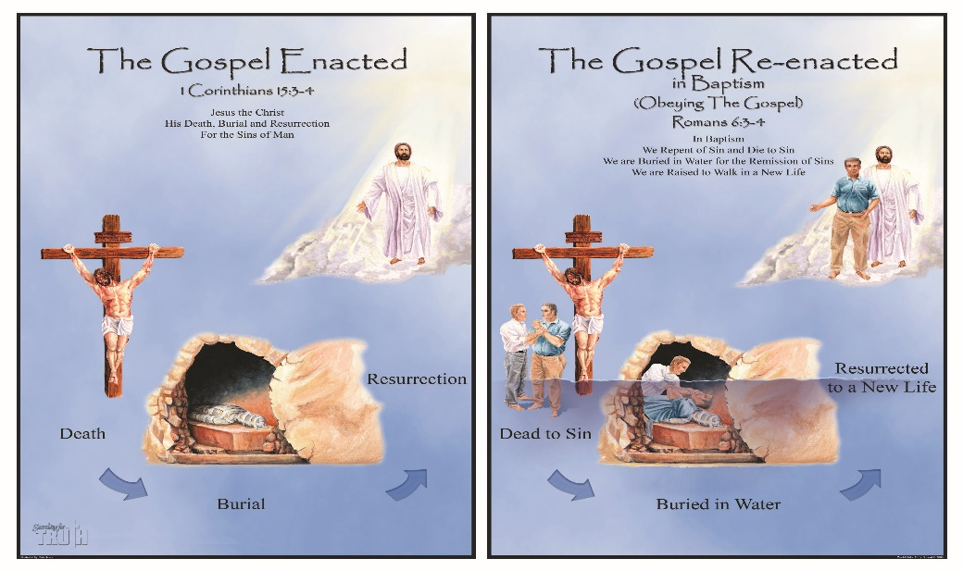

Do you believe with all your heart that God raised Jesus from the dead?

18. ______________________________

Are you willing to confess with your mouth the Lord Jesus before others?

19. ______________________________

Rom 10:8 But what saith it? The word is nigh thee, *even* in thy mouth, and in thy heart: that is, the word of faith, which we preach;

Rom 10:9 That if thou shalt 20. ________________________the Lord Jesus, and shalt 21. ____________________that God hath raised him from the dead, thou shalt be saved.

Rom 10:10 For with the heart man believeth unto righteousness; and with the mouth confession is made unto salvation.

Rom 10:11 For the scripture saith, Whosoever believeth on him shall not be ashamed.

Rom 10:12 For there is no difference between the Jew and the Greek: for the same Lord over all is rich unto all that call upon him.

Rom 10:13 For whosoever shall 22. ________

______________________shall be saved.

We must hear, believe, confess, and –

Is believing enough or must we obey?

23. __________________________________

Rom 10:14 How then shall they call on him in whom they have not believed? and how shall they believe in him of whom they have not heard? and how shall they hear without a preacher?

Rom 10:15 And how shall they preach, except they be sent? as it is written, How beautiful are the feet of them that preach the gospel of peace, and bring glad tidings of good things!

Rom 10:16 But they have **not** all 24. _______ __________. For Esaias saith, Lord, who hath 25. _____________ our report**?**

Rom 10:17 So then faith *cometh* by hearing, and hearing by 26. __________________.

We must obey the gospel or we are still in unbelief.

What will happen to a person who does not obey the gospel?

27. _________________________________

2Th 1:7 And to you who are troubled rest with us, when the Lord Jesus shall be revealed from heaven with his mighty angels,

2Th 1:8 In flaming fire taking **vengeance on them** that 28. ______________, and that 29. __________________of our Lord Jesus Christ:

2Th 1:9 Who shall be punished with 30. ____________________from the presence of the Lord, and from the glory of his power;

1Pe 4:17 For the time *is come* that judgment must begin at the house of God: and if *it* first *begin* at us, what shall the end *be* of them that 31. ____________________

__________?

The person who does not know God or does not obey the gospel of our Lord Jesus Christ will be eternally punished, and eternally separated from God and the power of his glory.

God’s power to save is in the gospel.

Rom 1:16 For I am not ashamed of the 32. ________________: for it is the 33. ________ ______________________to everyone that believeth; to the Jew first, and also to the Greek.

God as creator made that choice.

We as the created must follow His will and His plan.